I am from Vizag, and I have nearest datacenter available in Hyderabad/Chennai which is around 200 KMs away which cause latency, help me to resolve this

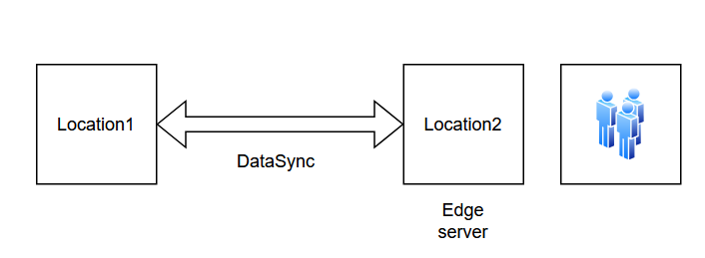

**🟦 1. Use Azure Front Door (AFD)**

AFD is a **global, high-performance edge network** that accelerates content delivery to your users.

| **Benefits** |
| --- |
| Serves content from nearest Microsoft POP (Point of Presence), e.g., **Chennai or Hyderabad** |
| Smart routing via Anycast + Microsoft global network |
| Layer 7 load balancing and SSL offloading |

**📌 How it helps:**  
Even though your backend is in Chennai, **AFD terminates traffic closer to Vizag**, reducing roundtrip time.

**📡 2. Azure Edge Zones or CDN**

If available in the region:

* **Azure Edge Zones** extend compute and storage closer to the edge — not yet in Vizag but may come in future.
* Use **Azure CDN (Verizon, Akamai, MS)** to cache static assets like JS, CSS, images **closer to Vizag users**.

**🔌 3. ExpressRoute with Local POP**

Azure **ExpressRoute** provides a private, dedicated network connection between your location (Vizag/on-prem) and Azure.

✅ Low latency  
✅ Reliable and secure  
✅ No exposure to the public internet

🧠 You can connect via a **Telco partner with a POP near Vizag** and extend to Azure Hyderabad region.

**🔀 4. Hybrid Setup (App Cache / Edge Compute)**

If latency is still too high, consider **splitting your application**:

| **Part** | **Hosted In** | **Reason** |
| --- | --- | --- |
| Frontend / Static UI | Vizag edge (on-prem or container) | Fast user interaction |
| Backend APIs | Azure (Hyderabad/Chennai) | Less sensitive to latency |
| DB | Azure or local cache + sync | Use caching for fast reads |

You can also use **Azure Stack Edge** or a local Kubernetes cluster for this.

**🧠 5. Smart Caching & Preloading**

* Use **Redis Cache** near backend
* **Preload resources** at the edge using CDN rules
* Store session state/data locally for reuse
* Use **lazy loading** for non-critical components